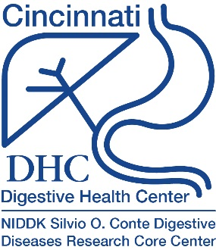
Digestive Health Center (DHC)
Annual Scientific Retreat

February 27, 2024

Abstract Submission Form

Instructions:

The deadline for abstract submission is Friday January 26, 2024 by 5:00 pm.

Use the format indicated on the next page and Arial 11-point font for your abstract.

You may include one figure with a figure legend.

Do not bold, underline, or italicize unless noted.

Do not delete the section headers listed in the text box on the next page.

Abstract limited to one page.

All abstracts will be combined into a single file and shared with the DHC community.

Save your abstract form as a Word File using the filename format of “Last Name First Name 2024 academic degree” (i.e. Wetzel Cindy 2024 PhD). Send the file including the name of the person who will be presenting the poster to cynthia.wetzel@cchmc.org.

PDF abstract submissions will not be accepted.

Abstract Presenter is:
☐ Graduate Student ☐ Research Associate

☐ Clinical Fellow ☐ Research Assistant

☐ Research Fellow ☐ Other ____________________

Submitting author is responsible for ensuring all authors have reviewed the abstract.
☐ Checking this box attests that this abstract has been reviewed by all
authors listed.

Title [Bold, Capitalize First Letter of Each Word]

Author [Include full first and last name of each author with superscripts referencing affiliation, i.e. Cynthia Wetzel¹ and Mya Moran²]

Affiliation [Include Division name and Institution with superscripts referencing author i.e. ¹Division of Gastroenterology, Hepatology and Nutrition, Cincinnati Children’s, ²Department of Biology, University of Cincinnati]
_____________________________________________________________________

Background and Aims:

Methods:

Results:

Figure
Figure Legend- XXXXX

Conclusions:

